Patient Participation Group
Patient opinion on measures introduced during national lockdown

The questionnaire

The future of GP services after the pandemic
Survey Monkey: https://www.surveymonkey.co.uk/r/22WRMXN QR code:
Google Forms: https://forms.gle/pZFJMQmNSfqSyzqD9

Let us know what works well for you and help us design our service when we reopen our doors.

We have continued working throughout the Covid-19/ Coronavirus pandemic (in fact we cancelled the Easter holidays and the VE Day holiday). To manage the lockdown, we introduced some new ways of providing services.
To plan ahead for the day we reopen, we would like to hear what services you find helpful.
[If you have other helpful suggestions, please contribute by email to alexandrasurgery@nhs.net]

- Have you used any GP service since the lockdown began (23 March 2020)?
[Please tick all the services you have used]
  - Consultation with GP or Nurse (by telephone, video or face to face)
  - Online consultation (e-Consult or DoctorLink)
  - Injection or wound care
  - Repeat prescription
  - Medical certificate
  - Medical letter
  - Other service
  - I did not use any GP service

- How did you contact the GP surgery?
[Please tick all the ways you have used]
  - Telephone the receptionist
  - E-mail
  - Fax
  - e-Consult
  - Emis Patient Access online
  - Reply to an SMS text message
  - Written note
  - via third party (for example, pharmacist)
  - I did not contact the surgery

- The lockdown in England is being relaxed. GP surgeries may reopen doors to the public.
Would you feel safe to come to the GP surgery?
  - Definitely would
  - Probably would
  - Probably woud not
  - Definitely would not

- During the lockdown, we ask patients to contact the surgery first before they come in. A doctor will call back, usually on the same day or next day. Often issues can be solved over the phone, if not then the doctor will arrange for the patient to attend the surgery.
Is this a useful service to keep after the lockdown?
  - Extremely useful
  - Very useful
  - Somewhat useful
  - Not so useful
  - Not at all useful

- e-Consult is an online service available 24 hours, 7 days a week. Patients can find health advice, arrange administrative help, request consultations, repeat prescriptions and medical certificates. The requests in patients' own words are saved in patient records, and read by doctors every working day.
Patients can access the service via our website; no registration or password is required, and there is no app to install.
The service was brought in after the lockdown, and planned to last for six months.
Is this a valuable service to keep after the lockdown?
  - Extremely valuable
  - Very valuable
  - Somewhat valuable
  - Not so valuable
  - Not at all valuable

- Patient Access lets patients connect to the Emis clinical system, so they can request repeat prescriptions or view their blood test results. The requests bypass the receptionist and go directly into the GP's mailbox first thing in the morning. Patients can also check when the prescription has been sent to the pharmacy.
You can log in from a desktop PC, laptop, tablet or mobile phone.
Are you likely to use this service after the lockdown?
  - Very likely
  - Likely
  - Neither likely nor unlikely
  - Unlikely
  - Very unlikely

- AccuRx clinical messaging system offers video consultation via the patient's smart phone, so the patient can see the doctor's face, and also show the doctor their concerns such as skin rash, red eye or discoloured nails.
Do you feel this service helpful to you as a patient?
  - A great deal
  - A lot
  - A moderate amount
  - A little
  - None at all

- Would you tell us a little about yourself? This data is anonymous.
What is your age?
  - Under 18
  - 18-24
  - 25-34
  - 35-44
  - 45-54
  - 55-64
  - 65+

- You consider your gender to be?
  - Female
  - Male
  - Other
  - I would rather not say

- Which ethnic group do you see yourself in?
  - WHITE: English / Welsh / Scottish / Northern Irish / British, Irish, Gypsy or Irish Traveller, Any other White background
  - MIXED / MULTIPLE ETHNIC GROUPS: White and Black Caribbean, White and Black African, White and Asian, Any other Mixed / Multiple ethnic background
  - ASIAN / ASIAN BRITISH: Indian, Pakistani, Bangladeshi, Chinese, Any other Asian background
  - BLACK / AFRICAN / CARIBBEAN / BLACK BRITISH: African, Caribbean, Any other Black / African / Caribbean background
  - OTHER ETHNIC GROUP: Arab, Any other ethnic group

The responses

Batch 1:
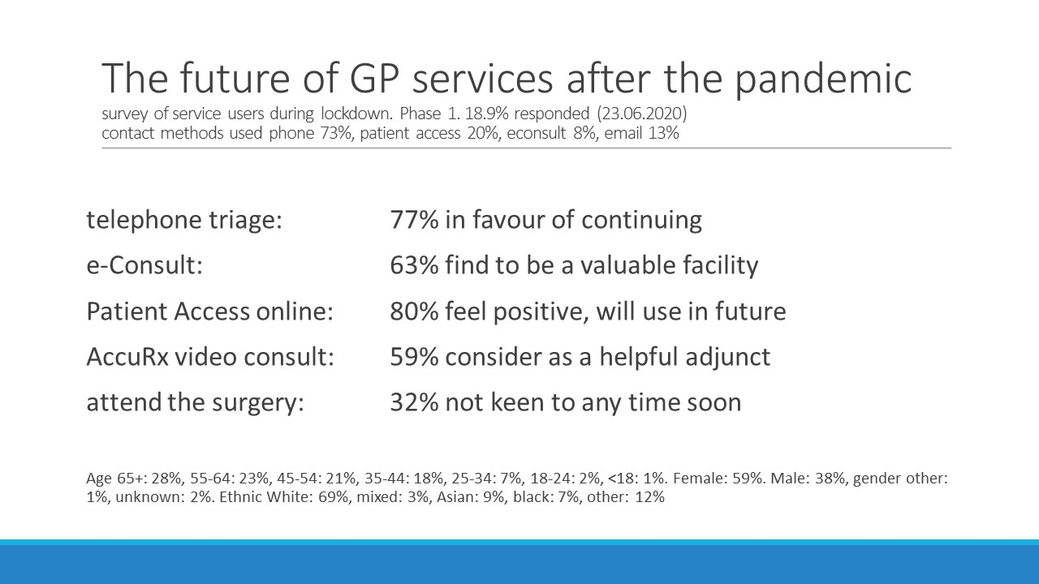

Batch 2:
